MOBILE PHONE - STORE MANAGEMENT SYSTEM

Software Requirements Specification
Version 1.0

Danang, Jan 2015

TABLE OF CONTENTS
TABLE OF CONTENTS 2
1. DOCUMENT HISTORY 3
2. REFERENCE DOCUMENTS 3
3. DISTRIBUTION LIST AND APPROVALS 3
4. INTRODUCTION 3
4.1 Purpose 3
4.2 In Scope 3
5. OVERVIEW 5
5.1 Actors 5
5.2 System Use Case Diagram 5
5.3 System Pages Flow 10
6. Functional Description 11
6.1 Search: 11
6.2 Add products 11
6.3 Remove products 15
6.4 Update 17
7. NON-FUNCTIONAL REQUIREMENTS AND OTHERS 20
Performance 20
Scalability 20
Security 20
Infrastructure 20
Reliability 20
Purchased Components 21
Interfaces 21
Extensibility 21
Assumption 21
8. APPENDIX 21

DOCUMENT HISTORY
Date | Summary of Changes | Version

REFERENCE DOCUMENTS
Document Name | Description

DISTRIBUTION LIST AND APPROVALS
This document is distributed to the following stakeholders to get their valuable comments and corrections.
Name | Title

INTRODUCTION

Purpose
- This project, Mobile phone store management system is a software allow manager to manage a mobile phone store, to keep staff and every selling activities under control, by this way, he is aware the status of his store,he could manage his budget and come up with a strategy business in order to get a maximum value from that.

In Scope
- The scope pertains to the Mobile Phone - Store Management. It focuses on the store, products, staffs, selling activities, delivering and applications, which allow for online sales, distribution and marketing.
- This SRS is also aimed at specifying requirements of software to be developed but it can also be applied to assist in the selection of in-house and commercial software products. The standard can be used to create software requirements specifications directly or can be used as a model for defining an organization or project specific standard. It does not identify any specific method, nomenclature or tool for preparing an SRS.

OVERVIEW

Actors
The below diagram describes all actors of the Mobile Phone - Store Management System. An actor represents a User Role; currently we have Administrator and Normal User Account. Each user has his own actions when accessing into the system.
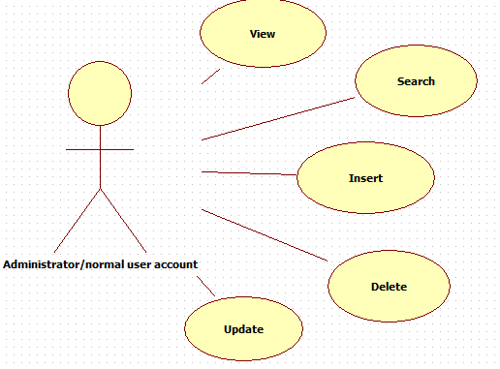
Actor | Description
Administrator | Has the right to View, Add new, Update and Delete data in all modules.
Normal User Account | Has the right to View, Add new, Update and Delete data in all modules, except User Accounts Maintenance.

System Use Case Diagram
The following diagram provides an overall picture of the functionality groups, Actors of the Mobile Phone - Store Management System. Mobile Phone - Store Management System’s functionalities are divided into these use cases:

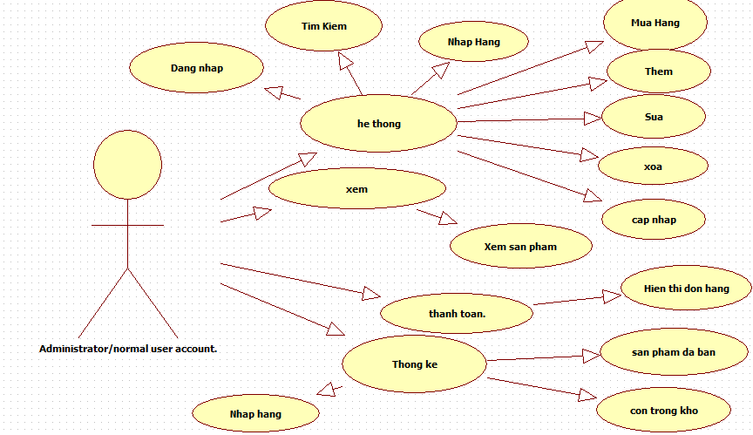
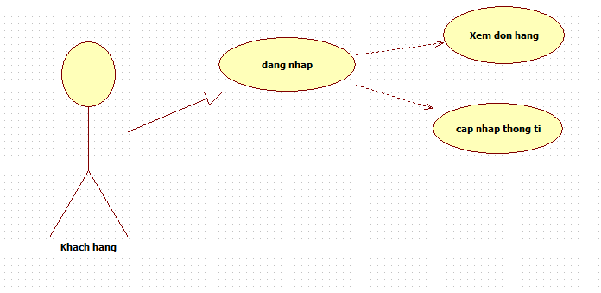

Biểu đồ tìm kiếm
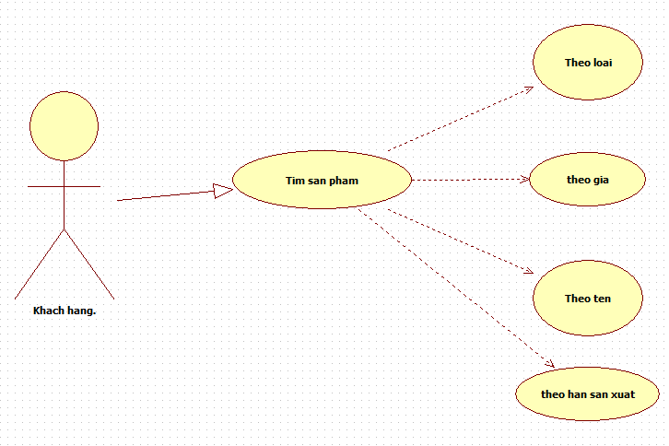

Biểu đồ nhập hàng vào kho
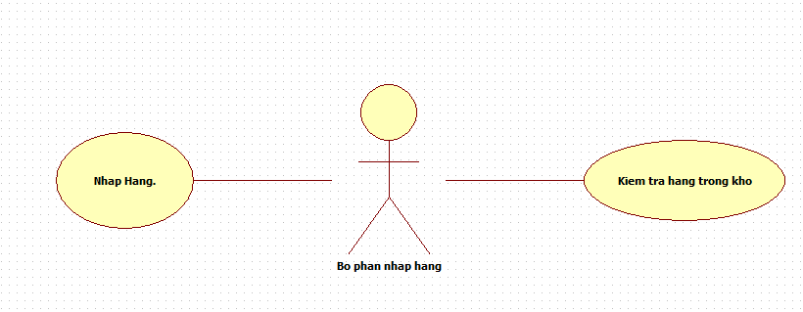

Biểu đồ thanh toán đơn đặt hàng
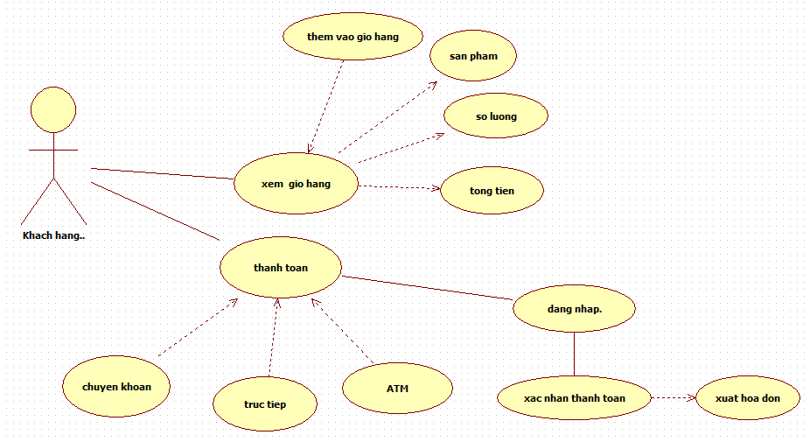

Biểu đồ thêm sản phẩm
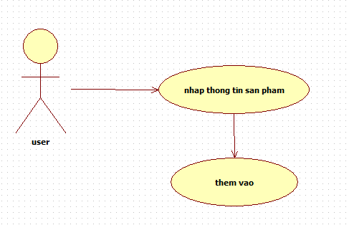

Biểu đồ chỉnh sửa sản phầm
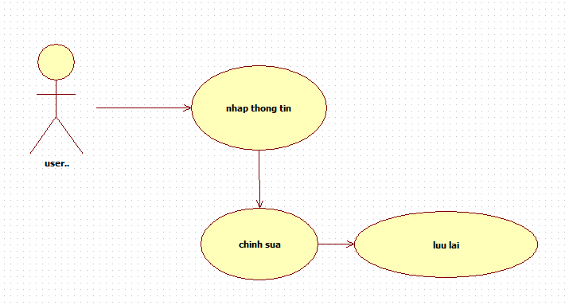

Biểu đồ xóa sản phẩm
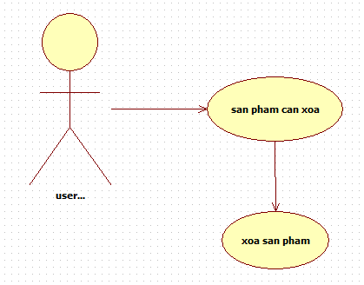

Biểu đồ liệt kê sản phẩm
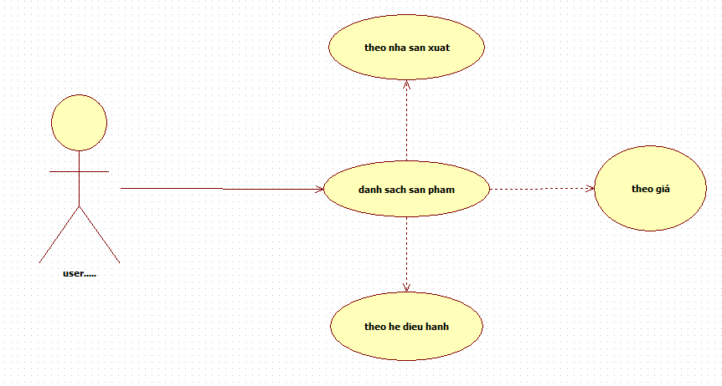

System Pages Flow
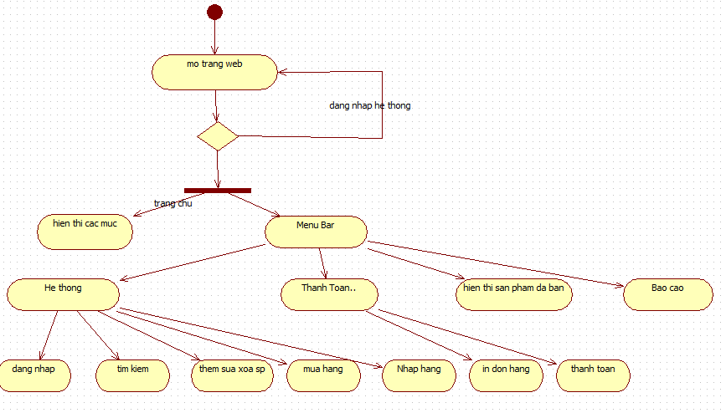

Functional Description

Search:
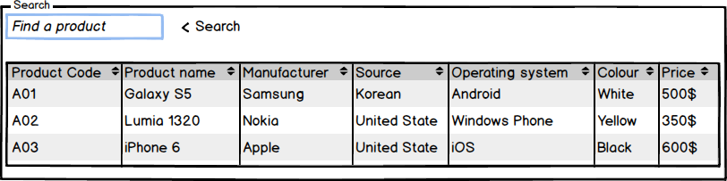
The shop must ensure that the customers can easily find the exact product they need.
The customer can find their desire product in the catalogue or listen to shop agent’s advices. The catalogue must be updated frequently, accurately, clearly, must be a computer-typing, try to avoid write it down by hand. Inside the catalogue, the shop can classify the products according to manufacturer, pricing… and more.
The shop’s agent check out the customer’s choice, if it available then create an export receipt. If not, the agent must say apologize to the customer and require him (her) chooses another products.

Add products
Use Case Name | Add products
Use Case ID | ABC001
High Level Requirement Ref | The general information about imported products must be prepared. The manager and the others members who have authority can view the product list. Besides that, they can make the order to import more products.
Actor | Shop’s Master, Warehouse Manager, Treas, Accountant
Description | This use case is used to add more products.
Pre-condition | The product is not available in the database.
Post-processing | The database has new products.

Screen Design

Add products – Filter
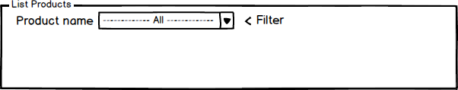
Screen | Add products – Filter
Description |  | Display query screen to filter displayed results. “All” value is set by default; the system displays all products information from the DB, on the screen. Then users can choose to display any product information, by choosing value in dropdown lists of Product Name.
Screen Access |  | Users click on the tab Products Management -> Add products
Screen Content
Item |  | Type | Data | Description
Product Name |  | Dropdown list - Alpha numeric (5) | Default: All  Lookup from PRODUCT.NAME - PRODUCT.CODE, ordered by PRODUCT.NAME | - Display both name and code but name first, value is code.  - User can type for searching, for example: user can type ‘S’ in the dropdown list and the system will show all products that started by ‘S’.
Screen Actions
Action Name |  | Description |  | Success | Failure
Filter |  | List of all products will be ordered by PRODUCT.NAME.  When users choose any value in the above dropdown list and click Filter button then the system returns data of that product. |  | Display general data of inputted Product code (data is selected from table PRODUCTS). | Displays message “No data found.” in the Message Area.

Add products – List

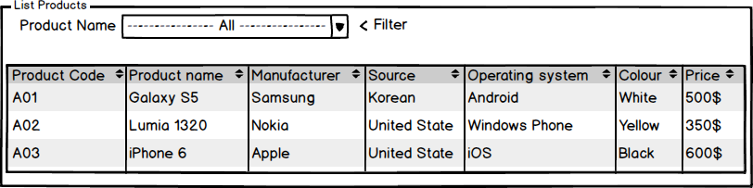

Screen | Add products – List
Description | Display all of available products in the database
Screen Access | Users click on the tab Products Management -> List
Screen Content
Item | Type | Data |  | Description
Product code | Link - Alpha numeric (5) | Lookup from PRODUCT.CODE |  | For users that are Administrators or Managers Accounts, then product code will be displayed as links, allow users to click on them, and go to “Update” screen.
Product name | Label - String (45) | Lookup from PRODUCT.NAME |  | Display the name of product
Manufacturer | Label - String (45) | Lookup from PRODUCT.MANU |  | Display the manufacturer of product, who make them.
Source | Label - String (45) | Lookup from PRODUCT.SOURCE |  | Display the source of product, where they come from.
Operating System | Label - String (45) | Lookup from PRODUCT.OS |  | Display the OS of the product.
Colour | Label - String (45) | Lookup from PRODUCT.COLOUR |  | Display the colour of product
Price | Label – Number (45) | Lookup from PRODUCT.PRICE |  | Display the price of product
Add | Button |  |  | For users that are Administrators or Manager Account, then this button will be displayed, allow users to click on, and go to “Add Products” screen.
Screen Actions
Action Name | Description |  | Success |  | Failure
Update | - If the user logged in is Administrator or Managers Account, then product codes are displayed as links.  - The user clicks on the link, then the system leads the user to “Update” screen. |  | “Update” screen is displayed. |  | Nothing
Add | - This button is only displayed if logged in user is Administrator or Managers Account. |  | “Add product” screen is opened. |  | Nothing

Add products – Add
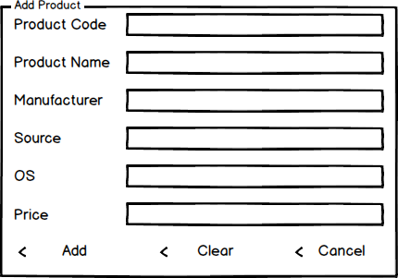
Screen | Add products – List
Description |  | Allow Administrator and Managers Account to add new products.
Screen Access |  | Users click on the button Add.
Screen Content
Item |  | Type | Data |  | Description
Product Code |  | Text field – Alpha numeric (5) | Inserted into PRODUCT.CODE |  | This field is mandatory.
Product Name |  | Text field – String (45) | Inserted into PRODUCT.NAME |  | This field is mandatory.
Manufacturer |  | Text field – String (45) | Inserted into PRODUCT.MANU |  | This field is mandatory.
Source |  | Text field – String (45) | Inserted into PRODUCT.SOURCE
Operating System |  | Text field – String (45) | Inserted into PRODUCT.OS |  | This field is mandatory.
Colour |  | Text field – String (50) | Inserted into PRODUCT.COLOUR
Price |  | Text field – Number (45) | Inserted into PRODUCT.PRICE |  | This field is mandatory.
Clear |  | Button |  |  | Clear all inputted data.
Add |  | Button |  |  | Add inputted data into database
Cancel |  | Button |  |  | Cancel to add new and back to “List” screen.
Screen Actions
Action Name |  | Description |  | Success | Failure
Add |  | Inputted data will be saved into the DB. |  | Back to the “List” screen with new record on the List (default list with all data).  When go back to the list from “Add” screen, the new record will be focused on. | Display message: “Database connection error.”  Display message “The product code is already exist in the system. Please enter a new product code.”  Display message:  “Product Code must be entered.”  Display message:  “Product Code must be in the format of alpha numeric”.  Display message:  “Product Name must be entered.”  Display message:  “Manufacturer must be entered”.  Display message:  “Price must be entered.”  Display message:  “Price must be a number”  Display message:  “Colour must be a text. Ex: black, red, blue…”
Clear |  | Clear inputted data. |  | Display “Add” screen with blank data.
Cancel |  | Close “Add” screen. |  | Return to the “List” screen (default list with all data).

Remove products

Screen Design

Remove products – Filter
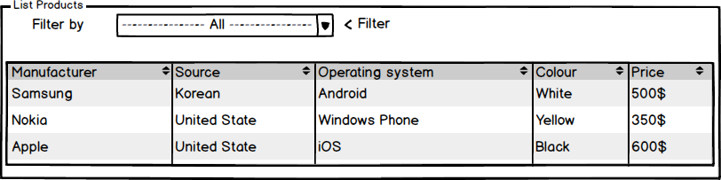
Screen | Remove products – Filter
Description |  | Display query screen to filter displayed results. “All” value is set by default; the system displays all products of all manufacturers and prices from the database. Then users can choose to display any product information, by choosing value in dropdown lists of Manufacturer, Price, Source, OS, Colour...
Screen Access |  | Users click on the tab Products Management -> Remove products
Screen Content
Item |  | Type | Data | Description
Manufacturer |  | Dropdown list – String (50) | Default: All  Lookup from PRODUCT.MANU, ordered by PRODUCT.MANU | Display product’s manufacturer name.  User can type free text to search for Manufacturer Name.
Price |  | Dropdown list – String (50) | Default: All  Lookup from PRODUCT.PRICE, ordered by PRODUCT.PRICE | Display the product’s price.
Source |  | Dropdown list – String (50) | Default: All  Lookup from PRODUCT.SOURCE, ordered by PRODUCT.SOURCE | Refers to the country of origin of the product.  User can type free text to search for Country Name.
Operating System |  | Dropdown list – String (50) | Default: All  Lookup from PRODUCT.OS, ordered by PRODUCT.OS | Information about product’s operating system (Android, iOS, Windows Phone…)
Colour |  | Dropdown list – String (50) | Default: All  Lookup from PRODUCT.COLOUR, ordered by PRODUCT.COLOUR | Return the colour of the products.
Screen Actions
Action Name |  | Description |  | Success | Failure
Filter |  | List of all products will be ordered by Product Name.  When users choose any value in the above dropdown lists and click Filter button, then the system returns data of that field. |  | Display general data of inputted above (data is selected from table PRODUCT. | Display message “No data found.” In the Message Area.

Remove product – List
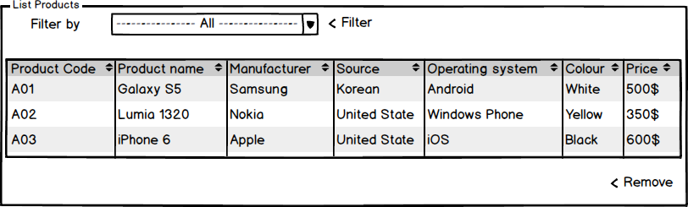
Screen | Remove product - List
Description |  | Display all products information base on the input field in the Filter
Screen Access |  | Users click on the tab Products Management -> Remove products
Screen Content
Item |  | Type | Data |  | Description
Product code |  | Link – String (50) | Lookup from PRODUCT.CODE |  | Display the product unique code.
Product name |  | Link – String (50) | Lookup from PRODUCT.NAME |  | For users that are Administrator or Manager Account, then product name will be displayed as links, allow users to click on them and ask they “Remove” or not.
Manufacturer |  | Label – String (50) | Lookup from PRODUCT.MANU |  | Display manufacturer of the products.
Price |  | Label – Int (50) | Lookup from PRODUCT.PRICE |  | Display price of the products.
Source |  | Label – String (50) | Lookup from PRODUCT.SOURCE |  | Number of staff of a particular vendor. Staff strength may change from time to time. The change will only affect new task.
Operating System |  | Label – String (50) | Lookup from PRODUCT.OS |  | Display OS of the products.
Colour |  | Label – String (50) | Lookup from PRODUCT.COLOUR |  | Display colour of the products.
Screen Actions
Action Name |  | Description |  | Success |  | Failure
Remove |  | - If the user logged in is Administrative or Manager Account, then Product Name are displayed as links.  - The user clicks on the item in the data grid view, then click on the “Remove” button to remove it. |  | “Remove” pop up is displayed.

Update
- Change the basic information of products (manufacturer, colour, source…)
- Change the product’s price.
- Add or remove special offer announcement.
- Update the product’s quantity.
- Update the product’s status.

Update products
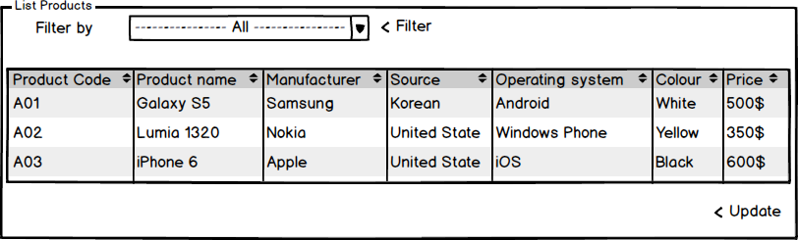
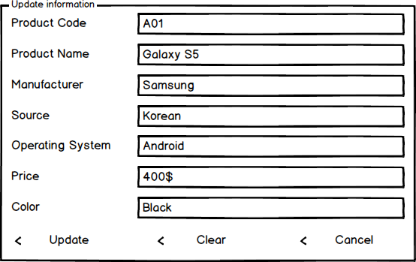
Screen | Manage – Update.
Description |  | Allow Administrator and Managers Account to update existing records.
Screen Access |  | Users click on the button to edit product.
Screen Content
Item |  | Type | Data |  | Description
Product Code |  | Text field – Alpha numeric (5) | This field is unique for each products.  Look up from PRODUCT.CODE |  | This field is mandatory.  A sequence number that auto generated by database will be used as foreign key to join primary table and reference table.  So that, when we update value of any item in the main table, then that value can be referenced by other tables using foreign key.
Product Name |  | Text field – String (45) | Look up from PRODUCT.NAME |  | Display the name of products.  This field is mandatory.
Manufacturer |  | Text field – String (45) | Look up from PRODUCT.MANU |  | Display the name of manufacturer.  This field is mandatory.
Source |  | Text field – String (45) | Look up from PRODUCT.SOURCE |  | Display the source of manufacturer.
Operating System |  | Text field – String (45) | Look up from PRODUCT.OS |  | Display the OS of manufacturer.  This field is mandatory
Price |  | Text field – Number (45) | Look up from PRODUCT.PRICE |  | Price of product.  This field is mandatory
Colour |  | Text field – String (45) | Look up from PRODUCT.COLOUR |  | Colour of product.
Clear |  | Button |  |  | Clear all inputted data.
Update |  | Button |  |  | Submit data.
Cancel |  | Button |  |  | Cancel update.
Screen Actions
Action Name |  | Description |  | Success | Failure
Update |  | Updated data will be saved into the DB. |  | Back to the “List” screen with updated record on the list.  If the user chooses to update a product from the list of all products, then when go back to the list from update, the updated record will be focused on. | Display message “The selected record has been removed by someone.”  Display message “The selected record has been changed by another user! Please refresh to get the latest data for your update.”  Display message: “Database connection error.”  Display message:  “Product Code must be entered.”  Display message:  “Product Code must be in the format of alpha numeric”.  Display message “The product code exists in the system. Please enter a new product code.”  Display message:  “Product Name must be entered.”  Display message:  “Manufacturer must be entered.”  Display message:  “Operating System must be entered.”  Display message:  “Price must be entered.”
Clear |  | Clear inputted data and reset to the previous data. |  | Display “Update” screen with the previous data.
Cancel |  | Close “Update” screen and return to the list. |  | Return to the “List” screen (previous list before going to “Update” screen).

NON-FUNCTIONAL REQUIREMENTS AND OTHERS

Performance
No. | Requirement
1. | Allow at least 10 users access at the same time
2 | Can run on computer with 512MB of RAM or higher, 1.7 GHz of CPU or higher, Windows XP 32bit or higher
3 | Used maximum 256MB of disk space (not include database)

Scalability
No. | Requirement
1. | Allow admin to limit the maximum of user access the system at the same time
2 | Allow developer to add more type of user with the different authority
3 | Allow admin to create more user account

Security
No. | Requirement
1. | Protect customer information
2. | Ensure the integrity, security of data
3 | Decentralize the user
4 | Protect internal information
5 | The system’s back-end databases shall be encrypted.

Network
No | Requirement
1 | Allow the manager to manag the store from home using the internet

Back up and restore
No | Requirement
1 | The system can synchronize automatically every day
2 | In case the system get error, it can restore, back to the status before getting error

Reliability
No | Requirement
1 | Only administrator can change product information
2 | Every changed of price have to be confirmed by the manager
3 | The system shall provide storage of all databases on redundant computers with automatic switchover.

Interfaces
No. | Requirement
1. | Font style is the same with http://www.customer.com.sg/default.aspx
2 | The GUI must have no more than 10 buttons each form
3 | The menu must have no more than 5 submenus
4 | Use the fresh color like the yellow green, blue, green, yellow .etc.

User manual and help
No | Requirement
1 | The software shall show the Use guide in the first running
2 | The software shall have a Help menu to show the Use guide in case users don’t know how to use or what is the purpose of the function

Extensibility
No. | Requirement
1. | Can add more table record without conflictions with the older
2. | Allow the developer to add more functions without conflictions
3 | The software can provide data to other application on other platform

APPENDIX

